A Wearable Assistive Device for Safe Travel using Transfer Learning and IoT for Visually Impaired

People

### Abstract There are a number of discomforts faced by visually impaired people every day in both indoor and outdoor surroundings. Assistive Technology for people with visual disabilities plays a vital role in their Independent living. Various systems have been developed to help them to live a better life even with the low or no vision. Visual Mobility plays a vital role in their Independent living such as arrival of buses, recognizing the Route Number from number plates, finding the doorstep in a train etc. This paper proposes an efficient approach for recognizing the Route details from a bus that helps in easy commuting in bus stations for the visually impaired. The You Only Look Once (YOLO v3) model can be used to detect the real time object bus and also segment the bus name board i.e. the Region of Interest (ROI) by transfer learning it with a custom dataset. To further improve the pattern recognition accuracy the numbers of anchoring boxes were increased from 3 to 5 in all the strides which provided more precise results. The route details present in the segmented ROI is converted into text using Tesseract tool that uses LSTM(Long Short Term Memory) engine for producing text from recognized characters in image and then regular expression is used to filter out only the bus number (alphanumeric or numeric values). The obtained bus number is converted as voice output (using text to speech library e-speak) along with bus details based on the bus number extracted from the number plate. An approach to detect the door step at railway compartments has also been proposed for visual mobility. During the travel, the device can be further used to know the current location and the distance remaining to reach the destination.

**Keywords** Pattern Recognition Deep Learning, Image Processing, Transfer Learning;

Corresponding Author Email: [sneham.research@gmail.com](mailto:sneham.research@gmail.com)

Co-author:[a.mathumathi99@gmail.com](mailto:a.mathumathi99@gmail.com),[nancysharonjohnson@gmail.com](mailto:nancysharonjohnson@gmail.com), [msanjaysivakumar@gmail.com](mailto:msanjaysivakumar@gmail.com)

1. **Introduction**

Globally the number of humans of all ages that are visually impaired is estimated to be around 285 million. Partial or complete loss of vision is common among most of the old age people and it is difficult for a person to deal with such kind of impairment after experiencing niche lifestyle with perfect vision. Visually impaired people has less ability to perform everyday task like other people so their quality of life gets affected and lose the ability to experience the necessary things in the world. Visually impaired people are comfortable only with their familiar places because they know the layout of the place and they would have memorized it, but when it comes to new environment they may find several difficulties. There are a number of technological advancements and everyday developments which are focused on providing a better lifestyle for handicapped and old age peoples. Although there are bright ideas and thoughts, there are practical difficulties in implementing them as a product that can be used every day by this section of the population.

One of the leading difficulties for visually impaired people in day to day scenarios is to travel alone without any dependencies from others. Some of them can have the blurry scene of a bus arriving at the bus terminal, still recognizing the bus route remains a challenging and an impossible task for them. People also feel embarrassed to request others to help them to identify bus numbers. Another major problem they face is in the railway stations. It is difficult for visually impaired person to choose which exit side of the train to use to get out from the train. Sometimes they accidentally trip over the wrong exit side and fall down to the track.

These type of incidents has occurred several times. These all leads to rise in demand to provide a simple and powerful solution to address these problems. Most of the time they are present alone in the station and they find it difficult to receive any assistance from other people. Numbers of bus recognition system ideas are introduced, like identifying the bus route with help of smartphone using Maximum Stable Extremal Regions (MSER) applications, or in another system histogram of the oriented gradient (HOG) identifies the codes of texts from detected text regions and produces output as audio notification. There are also systems introduced for bus detection using wireless networks and satellite signals. It requires installation of sensors and other modules in bus and bus stations along with periodic maintenance.

Most of these current systems lack performance required for real time detection and usage along with few other technical snags. There are a number of breakthrough researches and technologies coming out throughout the year. They highly involve attributes like quick performance, efficient methodologies, less implementation cost and many others. Therefore, coining enhanced solutions to all kinds of problems is not difficult and this includes for the above stated problems of visually impaired too.

1. **Review Of Literature**

In the research field of computer vision and in other areas a number of bus recognition systems are proposed; however, most of them use active devices and sensors such as Global Positioning System tracking system, RFID (Radio Frequency Identification), Beacons etc. For vision based approaches, P. Wongta [1] Introduced a system that uses MSER (Maximally Stable Extremal Regions) to recognize bus numbers. Their solution finds all the texts in an image rather than the required ones i.e. the bus number. Guida et al. [2] proposed a system for bus route number which uses a number of interlinked classifiers along with adaboost in order to identify the route number or other elements present in the front of the bus and some corrections are done to the extracted features to obtain rectified numeric values. The object is then converted to Hue, Saturation, Value (HSV) colorspace and then partitioning of each numeric or digit value. Finally Optical character Recognition (OCR) is used to identify the digits and output is produced as voice to the user. P. Viola and Jones [3] proposed a face detection framework that involved three key contributions which were integral images, ada boost and cascading classifiers. It was a simple and powerful technique to identify faces from binary images. Pan et al. [4] proposed a bus detection system to help the visually impaired where Histogram of the oriented gradients is used to extract features from bus images and a cascading Support Vector Machine model is implemented for a bus classifier to detect the bus facade in frames of windows. Tsai et al. [5] also introduced a system for bus detection to support the blind. The system included the functionalities of detection of the moving bus, bus panel detection and text detection from the text region of the panel. The system made use of MAFD(Modify Adaptive Frame Differencing) and was found to have great accuracy when features were extracted from different frames of the video .In [11] S.A Bouhmed used an ultrasonic sensor and camera in a walking cane to identify obstacles in the path and inform it to the blind. The system produces output through voice. Ebad Zahir et al. [17] developed a prototype of wearable head mountable device by customizing the Virtual Reality glass with ultrasonic sensors and HC-SR04 because it take minimum amount of time for detection and can also find obstacle in the longer range. The prototype is developed using Arduino. Ani R et al. [18 ] introduced a voice assistive text reading system that is integrated with eyeglasses. A Camera is inbuilt with the eyeglass to capture a image and with Tesseract-OCR text is extracted from the captured image. Open Software E-speak is used for TTS. There are a number of techniques and various innovative ideas proposed to help the blind. Most of these systems are dynamic and they have less difficulty when it comes to real time usage. Our proposed system is for real time usage and uses video recognition rather than capturing only images. The bus arrival and waiting time are always varying therefore every frame must be checked instead of single image snaps which would be less efficient for the detection of bus and bus board. The system proposed can be integrated with any of the existing ones, where the components are almost similar or it can be developed as a separate one in which any other new features can be extended.

1. **Overview of Proposed System**

Visually impaired people after loss of vision limits them from indulging in any activities that involves travelling in public transport facilities. They become hesitant to ask help from other people. For them to able to live their life independently we have developed Assistive Device for visually impaired to people that helps them to travel.

A single integrated system is developed to assist the visually impaired. User can choose the required operation by commanding through voice. Raspberry Pi serves the processing unit for all the operations and it is connected to an external portable power supply. An approach to accurately detect the real time bus object and to segment the ROI for extracting and recognizing the route details has been proposed to assist visually impaired people. An enhanced version of the You Only Look Once algorithm is proposed in this paper which detects the objects in an image at a single instance. It is an algorithm based on regression and it was pre trained on a number of classes.

The algorithm initially splits the image into cells of 19 x 19 grid and each cell is responsible for predicting 5 bounding boxes. Each of the bounding boxes can be described using 5 descriptors. They are,

1. Width (**bw**): Width of the bounding box.

2. Height (**bh**): Height of the bounding box.

3. Center of a bounding box (**bx by**): Center coordinates of the bounding box.

4. Value **c** : Corresponding to a class of an object (i.e. car, traffic lights)

5. Value **pc** : Probability that there is an object in the bounding box.

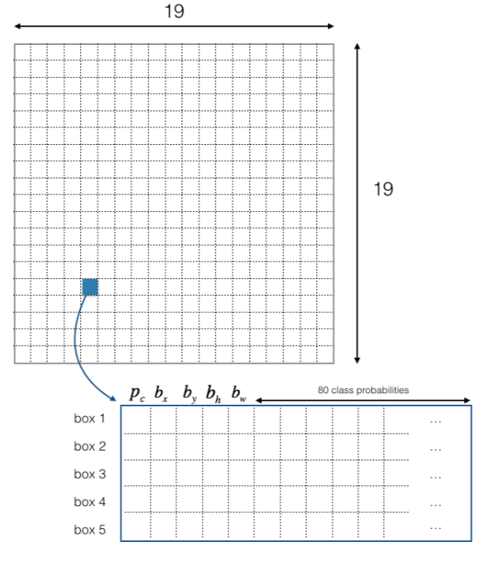

**Fig. 1** A 19 x 19 grid with descriptors **[** Source **:** https://pylessons.com**]**

For areas under each of the bounding box, the Convolution Neural Network (CNN) processes to identify to which class the object under the area belongs. The boxes with low object probability(pc) and unknown classes(**c**) are removed. Areas under high overlapping boundary regions across cells along with greater pc are the detected objects in the image. By transfer learning the YOLO v3 model with a custom dataset, the same above procedure is involved to detect the bus board in our system. The detected bus board image is then used to obtain the text with help of tesseract optical character recognition tool. It gathers the outlines into blobs by nesting. Blobs are further ordered into lines of text and each of these text lines are drilled down into probable terms and further into characters. Multiple passes are involved before finally predicting the character, words and the sentences. Latest versions of tesseract use deep learning frameworks which are accurate and fast. Output from the OCR is filtered with regular expressions which are constrained to find at maximum three characters length data that are either numeric or alphanumeric. The obtained data is the bus number as bus route number usually falls under these constraints in modern bus route naming systems. The identified bus number is informed to blind through text to speech method.

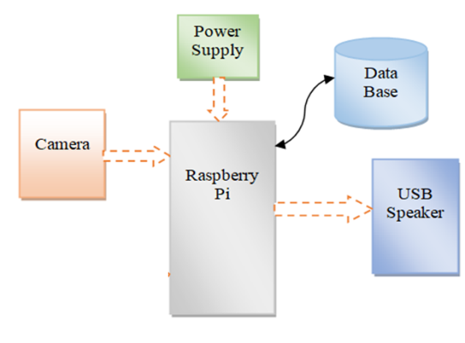

**Fig .2** Proposed System Components Architecture

Speaker/headphones are present to give output notifications. Microphone is used to obtain the voice input from the user. If the voice input is found to be difficult for the user or if there is a lot of noise, button inputs can be added to the system. GPS can be added as an extended feature which can inform the user where they are currently located and to know the remaining time it would take to reach the destination.

For railway platform detection, an Ultrasonic Sensor is present at a certain angle facing ground every time. It is also connected to the raspberry pi and it gives the frequent depth measures from ground to the pi in which the depth identification algorithm is executed. Speaker/headphones are present to give output notifications. Microphone is used to obtain the voice input from the user. If the voice input is found to be difficult for the user or if there is lot of noise, button inputs can be added to the system. GPS can be added as an extended feature which can inform the user where they are currently located and to know the remaining time it would take to reach the destination.

1. **Proposed Methodology**

The Proposed system mainly consists of two sub modules that are chosen for different scenarios by the user. A methodology to detect the real time object(bus) and segment the number plate (region of interest) has been proposed for recognizing the route number in a bus. In this approach, there are three sub modules involved. First the bus object is recognized and the bus board is segmented for which the core functionality is based on Convolution Neural Network and transfer learning. For the next module, tesseract optical character recognition engine is used to recognize the text and finally with regular expressions, the bus route number is recognized

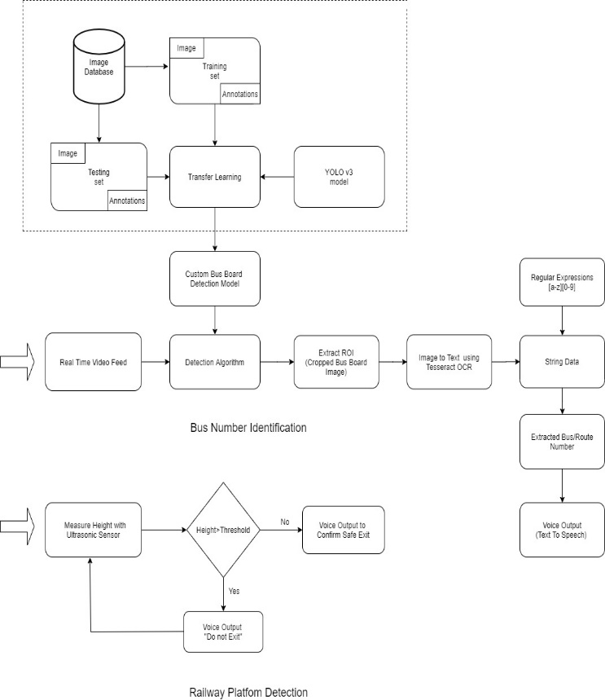

**Fig. 1** Overview of Proposed System

* 1. ***Bus Board Detection for Route Information Extraction***

This subsystem deals with identifying the bus board in real time. A high definition wide angle camera is mounted to the head wear and is connected to the pi. The camera is used to capture the bus arrival scene and from the video frames, ROI detection and extraction takes place.

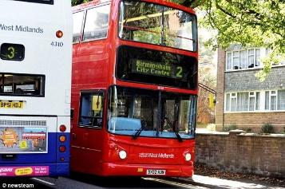

**Fig. 2**  Sample Training Images

More than 400 images were used to create a customized model. The images obtained were in a daylight environment. Preprocessing is done to remove the blurry and dark images before initiating the training process. The region of interests were marked and their labeling was given. Pascal visual object classes (VOC) is a format for providing object detection data, i.e. images with bounding boxes. Using the annotation tool, the bus boards are marked with bounding boxes in each image manually and these values are saved in a xml file. The bus boards are the Region of Interests for our model.

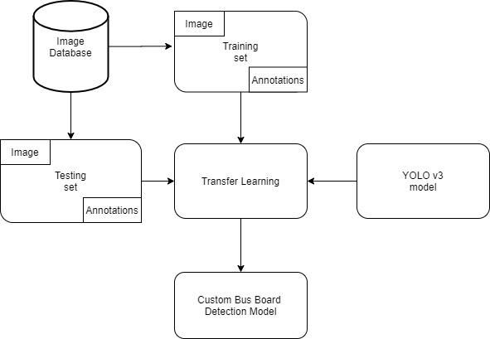

**Fig. 3** Building Custom Detection Model

Inorder to ensure that the trained custom models have better detection accuracy, transfer learning from a pretrained YOLO v3model was involved in the training. Transfer learning helps us to construct precise models in a timesaving way. Using transfer learning instead of starting afresh, we start from patterns that have been learned while addressing a different problem. Pre-trained model are used to initiate the transfer learning process.A pre-trained model is the one that is used to address a problem which is similar to a problem that we want to work out . A lot of computational costs are involved in training such models therefore models from well established literatures are used (e.g. MobileNet, VGG,  Inception, YOLO).

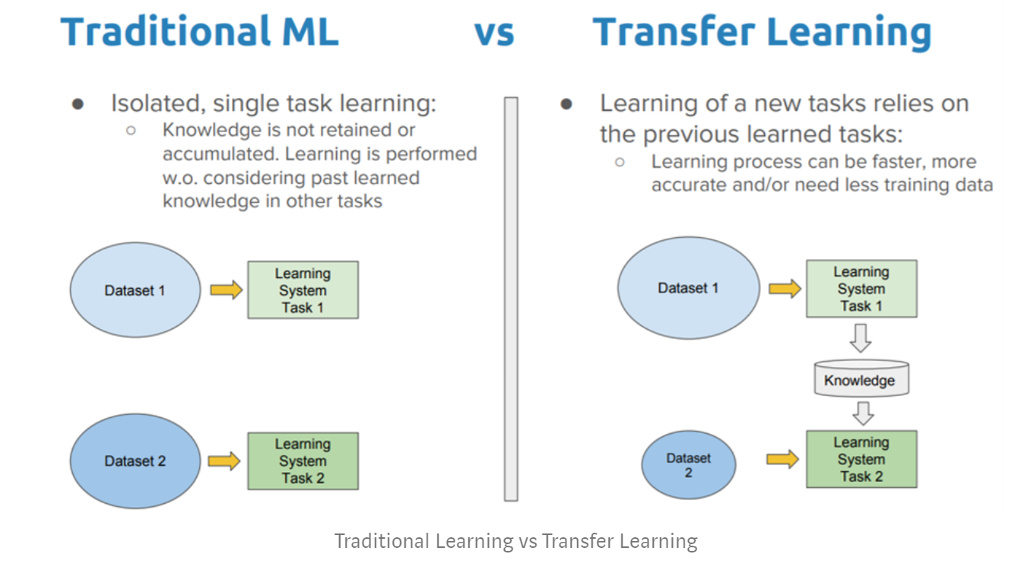

**Fig. 4** Traditional ML vs Transfer Learning **[**Source **:** [https://towardsdatascience.com](https://towardsdatascience.com/)**]**

You Only Look Once (YOLO) is a fully convolutional network model and its outputs are generated by applying a 1 x 1 kernel on a feature map. In YOLO v3, the detection is done by applying 1 x 1 detection kernels on feature maps of three different sizes at three different places in the model network. These places are known as strides. Each of these strides are used for processing large, medium and small images respectively.

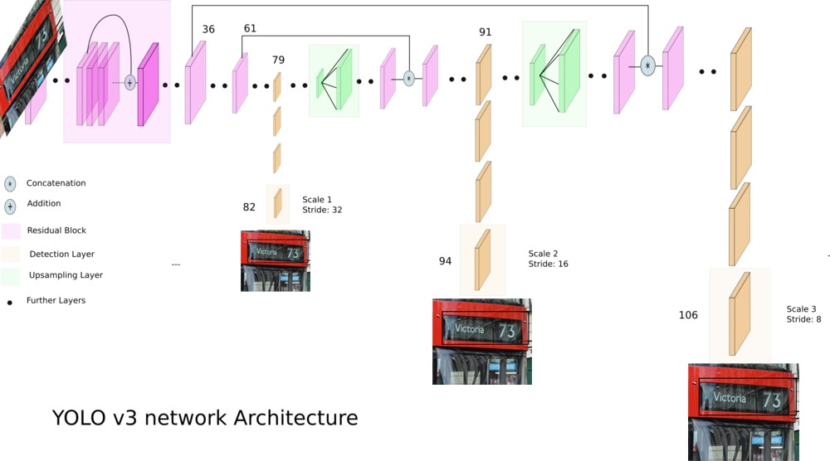

**Fig. 5** YOLO v3 Network Architecture**[** Source: [https://towardsdatascience.com](https://towardsdatascience.com/)**]**

Transfer learning with annotated images was completed along with a pretrained YOLOv3 model. The obtained customized model is saved for later usage in bus recognition and bus board identification. After training is done, the model is evaluated for accuracy. They are identified based on the decrease in the validation loss. In most cases, the lower or less is the loss, the more accurate the model will be in detecting required objects. However, some models may experience overfitting and have lower losses. Therefore, to ensure that the best model is picked for our custom detection, we evaluate with mAP (mean Average Precision) of all the trained models saved in the detection folder. The detection accuracy of the model is improved with better mAP.

* + 1. **Bus Object Detection**

The detection mechanism in a deep learning module mainly has two phases. In the first phase, an image is taken as an input and a number of blocks or boxes are formed around the possible entities with statistical features to label objects. Then this output is predicted to detect the object with its class name.

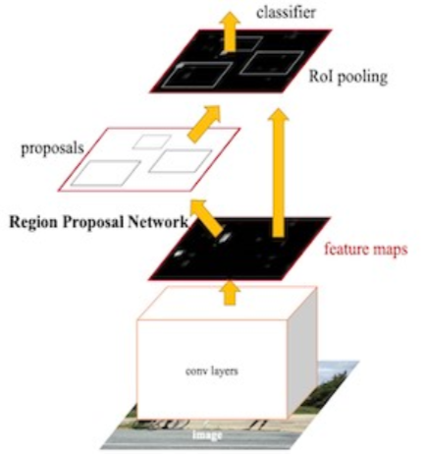

**Fig. 6**  Detecting ROI from random Image **[** Source : https://heartbeat.friz.ai **]**

The feature to identify the bus object comes from the pretrained YOLO v3 model which has a Convolutional Neural Network as underlying layer and there is no requirement to train the bus images separately for its identification process. The initial phase consists of a number of convolution layers and pooling layers through which the image pixel values move in an array format. Activation functions are present in the middle and through all of these, feature learning takes place. The next phase has flattened and fully connected layers with weights and before the final output classification is given soft maxing is done. The system moves to next processing only when the bus object is present in the video frame.

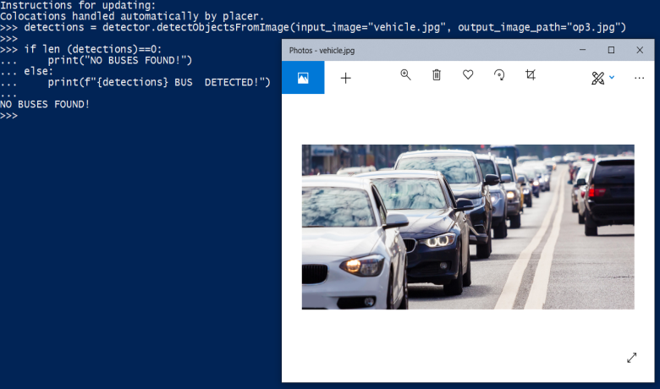

**Fig. 7(a)** Case 1- No buses recognized

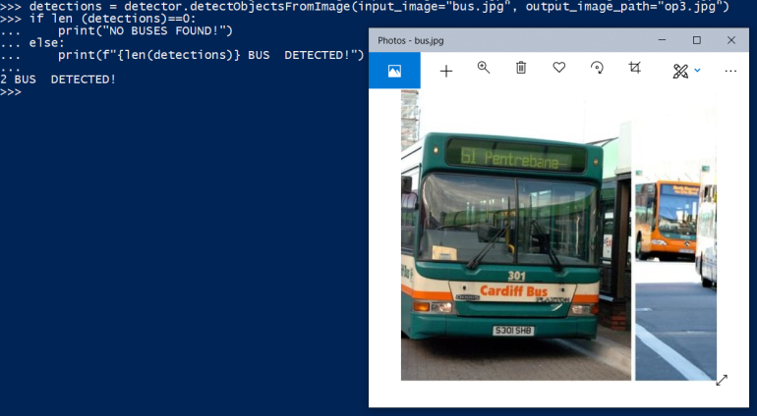

**Fig. 7(b)** Case 2- Two buses recognized

* + 1. **Bus Board Segmentation**

Our customized model is used for detection of bus boards from the video frames. For every frame, the detection algorithm is performed. The algorithm initially recognizes the bus. Then in the image, segmentation as 13 x 13 grids is done and each cell has a maximum of five bounding boxes. Prediction for each of the bounding box areas is made and scores are provided. If it is identified to be below the threshold value from the trained model, they are neglected. For the areas with overlapping bounding box boundaries, features are collected together and prediction scores are given. Along with them, confidence score is also present which gives distinction between that class (ROI) and rest of the background image. The bus board (Region Of Interest) is finally detected if it is present in the image. If there are multiple bus boards in the frame, the same technique is applied and all of them are extracted and they are saved as separate grayscale images which are used for the next operation i.e., Optical Character Recognition (OCR). It is necessary that the detected bus board image must not be blurry or dark as it makes it difficult for OCR operation.

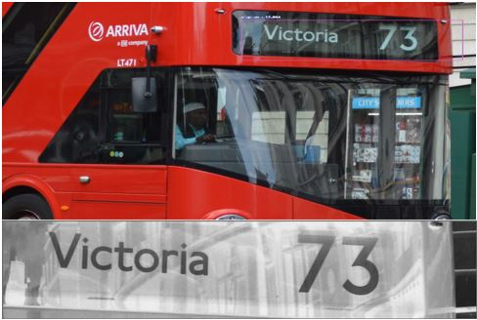

**Fig. 8**  Sample output of detected ROI (Bus Name board)

* 1. ***Route Recognition***

For obtaining text from an image. Tesseract OCR is used in our system. The latest recognition engine of tesseract is based upon Long Short Term Memory (LSTM).For the system pytesseract module is chosen as it acts as a replacement for the command line tesseract with specified configuration arguments. As all of the other modules are python based, we also make use of Tesseract OCR in python as pytesseract. Tesseract makes a two step approach for text detection. It makes use of adaptive recognition where in the initial step it identifies the pattern in letters, pixels, words and sentences, hence recognizing the characters. If it is not sure or successful in finding some characters, in the next step it tries to fill in with the character or word that matches the word or sentence context. In character recognition step the outlines are arranged into blobs by the nesting process.These blobs are then structured into lines of text and each of these text lines are broken into possible words and further into characters. Multiple passes are involved before finally predicting the character, words and the sentences. The process involves a number of iterations before final text is produced. In each iteration, the accuracy of recognition improves and finally finely converted text data is obtained**.**

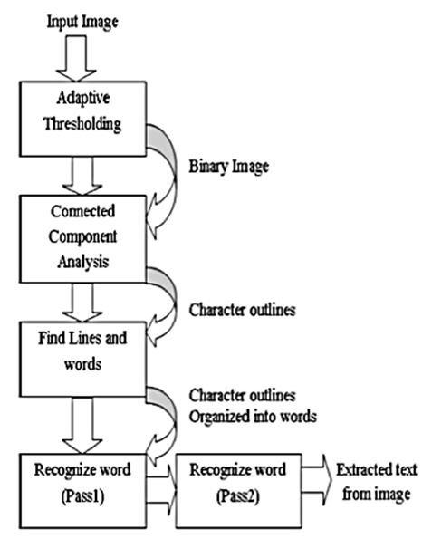

**Fig. 9** Working of Tesseract OCR **[**Source: [https://blog.cedric.ws](https://blog.cedric.ws/how-to-train-tesseract-301) ]

In our system all the information present in the bus board image is obtained by operating the tesseract tool on the image. This obtained text data is stored as string type data for further processing. For obtaining text with good accuracy, quality images are required from the previous module.

* 1. ***Text to Speech Conversion for Route Identification***

Regular expressions are defined to obtain the numeric or alphanumeric bus number from the text data stored in a text data format. A regular expression is a special text string for describing a search pattern. Strings of text are compared to the pattern in order to identify the string that matches the logical pattern defined by regular expression. On the basis of these comparisons the regular expressions can be used to identify strings of text that meet specific requirements or to validate that strings meet a required pattern. It is very important to define regular expressions properly because even if a single letter or number is missing, the route number becomes ambiguous.

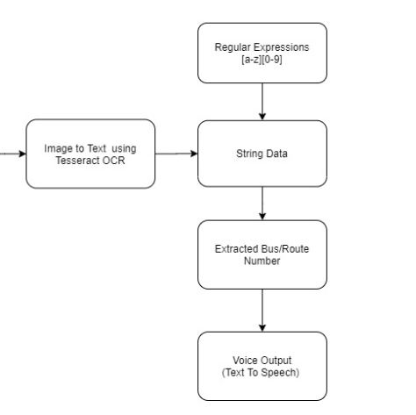

**Fig. 10**  Identifying Bus Number

The constraint laid for our regular expression is to work in a way such that it only extracts maximum 3 characters that are either numeric or alphanumeric and are continuous characters present one after another. The constraint is based in such a way because the bus numbers in the modern transport system are in numeric or in alphanumeric format and their characters length are usually two or three characters long. This constraint can be adjusted based on the locality requirements.

**Pseudo Code for Bus Number Identification:**

i- input image

t- String variable

ROI- Region of Interest

Img- Bus board image

RE- Regular Expression

Num- Bus Number

1. Initiate Function Identify_busnum()
2. i ← Capture()
3. Img ← ROI(i)
4. If data not in Img:
5. Suggest Capture()
6. Else:
7. t ← OCR(Img)
8. Num ← RE(t)
9. Voice (Num)
10. Query_db()
11. End!

An additional module, a database can be added to the system so that with the extracted bus number, all other information regarding the bus can be provided to the user. The bus number serves as the primary key with which the database is queried to provide details like destination location, stops present in the middle, ticket cost and other necessary information.

* 1. ***An IOT based Railway Platform Detection***

This subsystem involves detection of railway platform when train stops at the stations. An ultrasonic sensor is mounted to the headwear like cap/hat at a certain angle facing the ground. Initially the user’s height data is loaded in pi memory. This height along with a small variable length is added together and the value is stored as a prefixed threshold value . The variable length is the difference in height from platform to the train door. An ultrasonic sensor measures the distance based on the working given in fig.13.

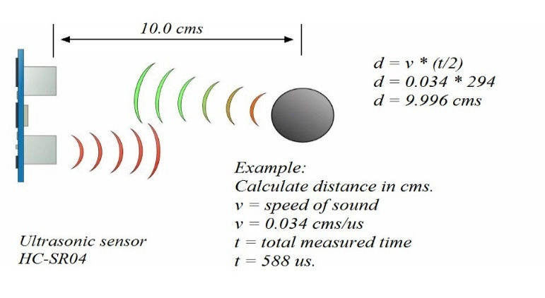

**Fig. 11** Working of an Ultrasonic Sensor **[**Source**:** [https://howtomechatronics.com](https://howtomechatronics.com/)**]**

The transmitter sends out waves which travels at the speed of sound waves (0.034cm/us) and the receiver obtains them when they are reflected back by an object or surface that is present in their path. The time difference(t) is noted and along with the known speed of the sound, distance value can be calculated(v*t/2) in the pi. The algorithm for the platform detection mainly identifies whether this measured distance exceeds the prefixed threshold value. If so, the user is notified quickly through speakers to get down on the other side of the train. Ultrasonic sensor is very much responsive therefore this operation takes place quickly. It is a light weight and simple process to assist the blind for safe exit from trains. The same methodology can be extended in future also for other transports. Some ambiguity may arise if there are obstacles present between the sensor and the ground/surface. This can be overcome by adding multiple ultrasonic sensors to the system.

**Pseudo Code**:

t- threshold distance

m- measured distance

1. Initiate function ultrasonic_measure(t)
2. While(true):

Find m

* 1. If m>t:
     1. Voice(“danger”)
     2. Continue
  2. Else:
     1. Exit Loop

1. End!

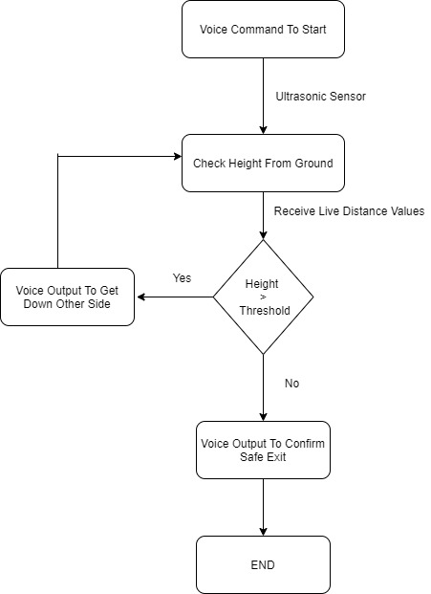

**Fig. 12** Flow diagram for Platform Detection

* 1. ***Assistive Device For Visual Mobility And Safe Travel***

A single integrated system is developed and the whole system is attached to a cap to assist the visually impaired. User can choose the required operation by commanding through voice or using a button. Raspberry Pi serves the processing unit for all the operations and it is connected to an external portable power supply.

For bus identification, a High Definition wide angle camera is used and the real time feed starts once bus number identification operation is chosen to obtain the bus number and all other details.

For railway platform detection, an Ultrasonic Sensor is present at a certain angle facing ground every time. It is also connected to the raspberry pi and it gives the frequent depth measures from ground to the pi in which the depth identification algorithm is executed. Speaker/headphones are present to give output notifications. Microphone is used to obtain the voice input from the user. If the voice input is found to be difficult for the user or if there is lot of noise, button inputs can be added to the system. GPS can be added as an extended feature which can inform the user where they are currently located and to know the remaining time it would take to reach the destination.

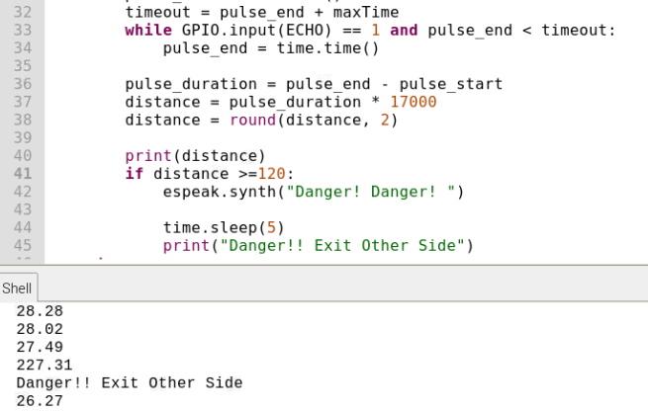

**Fig. 13** Results of IOT based Railway Platform Detection

1. **Implementation and Results**

More than 400 images were chosen as a dataset to create a customized model to detect the bus board. The initial accuracy was computed from the ability of the model to find whether buses were correctly recognized in the images (i.e. for bus recognition). Thirty traffic images with vehicles were taken and the model was made to identify whether buses were present in the image or not. Out of thirty predictions twenty seven right predictions were made by the system. Hence the accuracy was found to be 0.9 out 1 i.e. 90%. Sample predictions are given in Fig.9(a) & 9(b).The comparative performance analysis is shown in Table 1.

Fifty random bus images were chosen in order to test the accuracy of the bus board detection model. Although there were cropped edges, the region of interest was properly extracted. The accuracy is identified by calculating the ratio of number of properly extracted images to the total number of images chosen. The accuracy was found to be 0.74 out of 1 i.e. 74% with the native algorithm. The accuracy improved by 6% for the same dataset by enhancing the algorithm which includes an increase in the number of anchor boxes in the cells of the image.

## 

**Fig. 1** Detected Bus Board Images

## 

Compared to accuracy of models proposed using HOG, SVM, and CNN, our system has been identified to be more accurate. It has also been noted that the proposed solution is quick as it makes use of the power YOLO object detection model. The comparisons are only based on accuracy of the bus board detection as the data sets involved and other configurations are different in all three models shown in Table 1 and Fig 16.

## **Table 1:** Comparative Performance Analysis

|  |  |  |  |
| --- | --- | --- | --- |
| ***Method*** | ***Total no.of images used for identifying accuracy(a):*** | ***No. of properly processed images(b):*** | ***Accuracy (b/a):*** |
| *HOG and SVM* | 50 | 36 | 0.72 |
| Yolo *method* | 50 | 37 | 0.74 |
| *Enhanced Yolo* *method* | 50 | 40 | 0.8 |

**Fig. 2** Comparative Performance Analysis of Proposed System

1. **Conclusion And Future Work**

In this paper, we propose a system that helps visually impaired mobility in bus stations in real time. We hope with this kind of system, their lifestyle can be improved and their stress from fear of meeting with any kind of accident while travelling can be reduced. The system proposed can be integrated with existing devices or they can be implemented as a separate one. GPS and location tracking can be further added so that the user can know where they are exactly, distance remaining and time that will be taken to reach the destination. The system can be connected with the smartphone for booking cabs or other transportations and inform the user when the vehicle arrives by identifying the vehicle register number or if any QR code/Magnetic Tags are present in the vehicle.

**REFERENCES**

* + - 1. P. Wongta, T. Kobchaisawat, and T. H. Chalidabhongse, “An automatic bus route number recognition,” in Proc. of the IEEE Int. Conf. on Computer Science and Software Engineering (JCSSE), Khon Kaen, Thailand, pp. 1–6, 2016.
      2. C. Guida, D. Comanducci, and C. Colombo, “Automatic Bus Line Number Localization and Recognition on Mobile Phones—A Computer Vision Aid for the Visually Impaired,” in Image Analysis and Processing – ICIAP 2011, G. Maino and G. L. Foresti, Eds. Springer Berlin Heidelberg, pp. 323–332, 2011.
      3. P. Viola and M. J. Jones, “Robust Real-Time Face Detection,” Int. J. Comput. Vis., vol. 57, no. 2, pp. 137–154, May 2004.
      4. H. Pan, C. Yi, and Y. Tian, “A primary travelling assistant system of bus detection and recognition for visually impaired people,” in IEEE International Conference on Multimedia and Expo Workshops (ICMEW), pp. 1–6, 2013.
      5. C. M. Tsai and Z. M. Yeh, “Text detection in bus panel for visually impaired people "seeing" bus route number,” in 2013 International Conference on Machine Learning and Cybernetics (ICMLC), vol. 03, pp. 1234–1239, 2013.

1. “SceneTextDetection.”[Online].Available:http://docs.opencv.org/3.0beta/modules/text/doc/erfilter.html#erfilter.
2. L. Neumann and J. Matas, “Real-time scene text localization and recognition,” in the 2012 IEEE Conference on Computer Vision and Pattern Recognition (CVPR), pp. 3538–3545 , 2012.
3. L. Gómez and D. Karatzas, “Multi-script Text Extraction from Natural Scenes,” in 2013 12th International Conference on Document Analysis and Recognition (ICDAR), 2013, pp. 467–471.
4. J. Matas, O. Chum, M. Urban, and T. Pajdla, “Robust wide-baseline stereo from maximally stable extremal regions,” Image Vis. Comput., vol. 22, no. 10, pp. 761–767, Sep. 2004.
5. S. A. Bouhamed, J. F. Eleuch, I. K. Kallel, D. S. Masmoudi, "New electronic cane for visually impaired people for obstacle detection and recognition", *Proc. IEEE Int. Conf. Veh. Electron. Safety (ICVES)*, pp. 416-420, Jul. 2012.
6. T. Kobchaisawat and T. H. Chalidabhongse, “Thai text localization in natural scene images using Convolutional Neural Network,” in Signal and Information Processing Association Annual Summit and Conference (APSIPA), 2014 Asia-Pacific, 2014, pp. 1–7.
7. G. Singh, R. Kumar and P. Kashtriya, "Detection of Potholes and Speed Breaker on Road," *2018 First International Conference on Secure Cyber Computing and Communication (ICSCCC)*, Jalandhar, India, 2018, pp. 490-495
8. A Comprehensive Hands-on Guide to Transfer Learning with Real-World Applications in Deep Learning - https://towardsdatascience.com/a-comprehensive-hands-on-guide-to-transfer-learning-with-real-world-applications-in-deep-learning-212bf3b2f27a
9. The 5 Computer Vision Techniques That Will Change The World:https://heartbeat.friz.ai/the-5-computer-vision-techniques-that-will-change-how-you-see-the-world-1ee19334354b
10. C. Verstraeten, "How to train Tesseract 3.01 - Cédric Verstraeten," 16 02 2017. [Online]. Available: <https://blog.cedric.ws/how-to-train-tesseract-301>
11. Zahir, E., Hossain, M. S., Iqbal, M. W., Jalil, I., & Kabir, S. M. (2017). Implementing and testing an ultrasonic sensor based mobility aid for a visually impaired person. 2017 IEEE Region 10 Humanitarian Technology Conference (R10-HTC).
12. Ani R, Effy Maria, J Jameema Joyce, “Smart Specs: Voice Assisted Text Reading system for Visually Impaired Persons Using TTS Method,” IEEE International Conference on Innovations in Green Energy and Healthcare Technologies, Nov 2017.

**BIOGRAPHY**

**Dr.R.Priyatharshini** received her BE degree from University of Madras in 2001 and ME degree from Anna University in 2008. She has completed her PhD degree 700 from Anna University in 2017. She has 18 years of teaching experience and currently working as an associate professor in Easwari Engineering College, Chennai. She has published more than 20 research papers in International Conferences and Journals. Area of interest towards data science,machine learning,deep learning and medical image analysis. She is a life time member of Institution of Engineering and Technology.

**Sanjay Sivakumar M** is a student of Easwari Engineering College, pursuing final year of his B.Tech in Information Technology. His area of interest includes Computer Vision, Deep  Learning and Machine Learning. He is currently working as software engineer trainee under retail domain in Tata Consultancy Services Ltd. He was a member of Rotaract Club of Srm Easwari Engineering College and has done many services as a Public Relations Officer of the club.

**Mathumathi.A**  is completed her B.Tech Information Technology from Easwari Engineering College. Her area of interest is towards Machine Learning and Deep Learning. She is currently working as Graduate Engineer Traineer in a financial service company TVS Credit Services Limited. She was a member of Rotract Club of Easwari Engineering College and organised many events for social cause.

**Nancy sharon Johnson** completed B.Tech degree in Information technology from Easwari engineering college .Her area of interest is towards Machine Learning and Deep Learning. She is currently working as a Graduate Engineer Trainee in a L&T Infotech. She was a member of Youth Red Cross Club. She acted as a volunteer in many social service activities.